Welcome & Opening Words

Prelude: The Sweetest of Dreams -- composed by Melody Bober

Chalice Lighting Words by Jo VonRue
We light this chalice knowing that liberation of oneself is about loving that which is deep inside, may the flame of both fear and confidence abide in harmony within each of us as we work toward the liberation of our own hearts and minds.
Morning Song Sung in unison. Please rise in body or spirit.
From all that dwells below the skies,
Let songs of hope and joy arise,
Let peace, good will, on earth be sung,
In all the land, by every tongue.

Opening Affirmation Spoken in unison. Please rise in body or spirit.
Blessed be this time together
as people of the church universal,
diverse in our searchings,
but united by a common bond
of love and acceptance.

We give thanks today
for the interconnected web of life,
the holiness of the ordinary,
the sacredness of each day,
the power of love to overcome hatred,
and the guiding spirit of truth which never deserts us.

We have been brought together
as people of the open covenant,
to care for each other and the world
and for a purpose that transcends
even our own understanding.
Rev. Dr. John Morgan, 1991 (adapted)

Expression of Joys and Concerns
(Light a Candle or Drop Shells into Water)

First Hymn: #346 - Come Sing a Song With Me
Please rise in body or spirit.
Time for All Ages
Antiphonal Reading by Jean M. Olson
Go Boldly
May you be brave enough to expose
your aching woundedness
and reveal your vulnerability.
May you speak your deepest truths,
knowing that they will change as you do.
May you sing the music within you,
composing your own melody,
playing your song with all your heart.
May you draw, paint, sculpt, and sew,
showing the world your vision.
May you write letters, poetry, biography,
slogans, graffiti, the great novel,
laying bare your words to love and hate.
May you love even though your heart
breaks again and again.
And until the end of your days,
may your life be filled
with possibilities and courage.

Offertory: Daybreak in Dublin -- composed by Melody Bober
One half of today’s non-pledge collection will go to the NEPA Rainbow Alliance. Their mission is to provide support, education and advocacy for LGBTQA individuals and families while working for fairness and equality. Follow on FACEBOOK for events, and volunteer opportunities. You can also contact Kennie Harr at (570) 283-4291, kennie.harr@verizon.net

Spoken Meditation followed by a moment of silence and hymn
Silent Meditation
Hymn: #391 - Voice Still and Small
(please remain seated

Sermon: Title A Pocket, Full of Liberation Speaker Jo VonRue

Part One: Eve After the Fall

Reading: Autobiography of Eve by Ansel Elkins
Part Two: The Liberation of Eve

Reading: “If We Do Not Venture Out” by Marni Harmony (adapted)

Part Three: The Eve in Each of Us

Hymn: #298 - Wake, Now, My Senses

Chalice Extinguishing Spoken in Unison. Please rise in body or spirit.
In things essential, unity.
In things circumstantial, liberty.
In things yet to be, courage.
And in all things, wisdom.

Benediction “The Hand in Yours” by Erika Hewitt
Postlude: To Catch A Dream -- composed by Martha Mier
Congregational Announcements
Please join us for coffee and refreshments.

“Our mission is to provide a welcoming and supportive community which values and embraces diversity, seeks peace and justice through social action, and nurtures lifelong spiritual growth for ourselves and others.” (See page x of your hymnal for the Seven Principles of Unitarian Universalism.)

Acknowledgments
We welcome, Jo VonRue, Andita Parker Lloyd, and Valerie Kepner and we thank them for sharing their words and music with us this morning.

Announcements are available in the vestibule.
To receive the announcements electronically, please send an e-mail to uucwv91@gmail.com, with “mailing list” in the subject line

UNITARIAN UNIVERSALIST CONGREGATION OF WYOMING VALLEY
Member of the Unitarian Universalist Association of Congregations
Office: PO Box 2608, Wilkes-Barre, PA 18703-2608
Tel: (570) 696-3949
E-mail: uucwv91@gmail.com Web: http://uucwv.org

Unitarian Universalist Congregation
of
Wyoming Valley

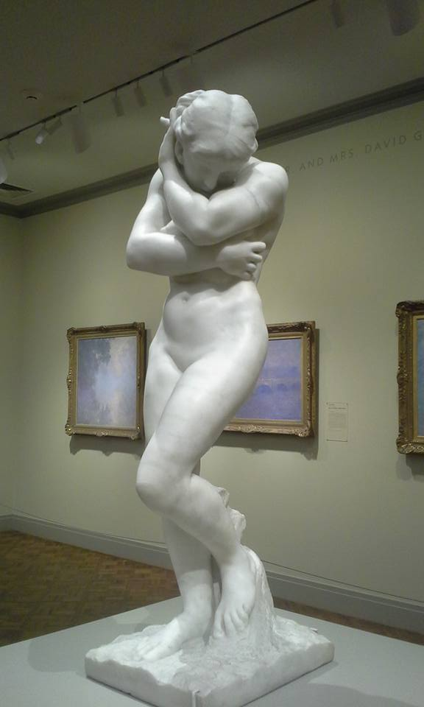

"Eve After The Fall"
1886
Auguste Rodin

Sunday, March 6, 2016

